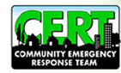

Do You Know What To Do In An Emergency?
The Heard County Community Emergency Response Team (CERT) prepares you to take care of yourself, your family, and your community.
Classes ARE FREE!
Please join us Tuesday, February 7, at the Heard County Emergency Services Training Center, 11816 Hwy 100, Franklin, starting at 6:30 p.m., For more information please call Marie Russell 770-301-9391 or email whipfist@aol.com or Chief Cumbie 706-675-6186.
When you are trained, you are far more equipped to deal
with your circumstances without needing aid from outside sources.

